**ARNOLD DAVID MEJIA TABORA 0419200100189**

TAREA #1 DE SIST. AUTOMATIZADOS PER I 2022

PROBLEMA 1

Dado el siguiente diagrama de compuertas lógicas, obtenga la señal resultante de insertarlas señales A, B, C, y D en el mismo, conforme al cronograma que se muestra.

La entrada de K es 1.

|  |  |  |  |  |  |  |  |  |  |  |  |  |  |
| --- | --- | --- | --- | --- | --- | --- | --- | --- | --- | --- | --- | --- | --- |
|  |  |  |  |  |  |  |  |  |  |  |  |  |  |
|  |  |  |  |  |  |  |  |  |  |  |  |  |  |
|  |  |  |  |  |  |  |  |  |  |  |  |  |  |
| A |  |  |  |  |  |  |  |  |  |  |  |  |  |
|  |  |  |  |  |  |  |  |  |  |  |  |  |  |
| B |  |  |  |  |  |  |  |  |  |  |  |  |  |
|  |  |  |  |  |  |  |  |  |  |  |  |  |  |
| C |  |  |  |  |  |  |  |  |  |  |  |  |  |
|  |  |  |  |  |  |  |  |  |  |  |  |  |  |
| Q |  |  |  |  |  |  |  |  |  |  |  |  |  |
|  |  |  |  |  |  |  |  |  |  |  |  |  |  |
|  |  |  |  |  |  |  |  |  |  |  |  |  |  |
| 2 |  |  |  |  |  |  |  |  |  |  |  |  |  |
|  |  |  |  |  |  |  |  |  |  |  |  |  |  |
|  |  |  |  |  |  |  |  |  |  |  |  |  |  |
|  |  |  |  |  |  |  |  |  |  |  |  |  |  |
| 3 |  |  |  |  |  |  |  |  |  |  |  |  |  |
|  |  |  |  |  |  |  |  |  |  |  |  |  |  |
|  |  |  |  |  |  |  |  |  |  |  |  |  |  |
|  |  |  |  |  |  |  |  |  |  |  |  |  |  |



3

1

2

1

K

Q

Dado el siguiente diagrama de FLIP FLOP, obtenga la señal resultante **Q**  de LAS señales insertadas en el mismo, conforme al cronograma que se muestra.



**Q**

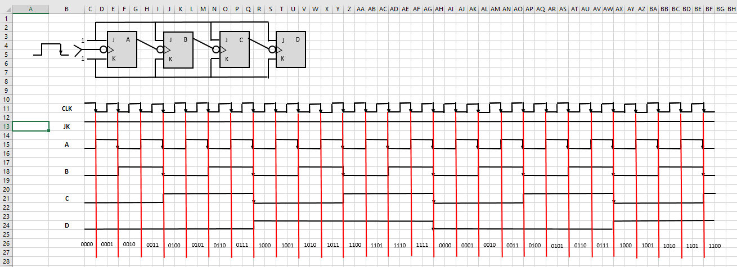Ejercicio

